1. GGM

1.1 single stage

P0 = D1/(Re-g)

1.2 two stage

t = 5

D1 = D0 \* (1+g1)

...

D5 = D4 \* (1+g1)

D6 = D5 \* (1+g2)

TV5 = D6 / (Re - g2)

CF:

CF5 = TV5 + D5

CF4 = D4

CF3 = D3

CF2 = D2

CF1 = D1

1.3 three stage

1.4 h model

第二行中间的

P0 = D0(1+g2) / (Re-g2) + D0(g1-g2)\*t/2 / (Re-g2)

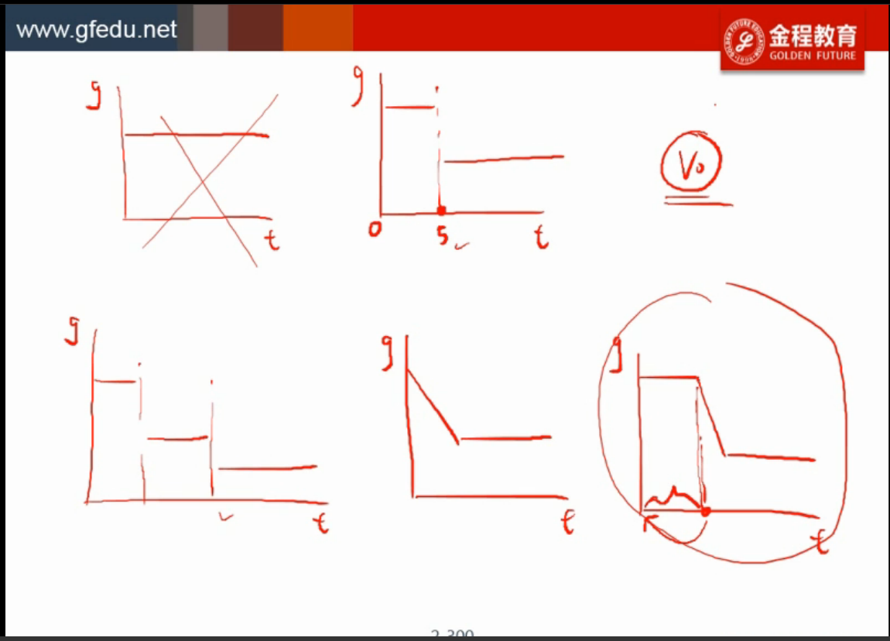

1. PVGO

2.1 概念

相当于假设把当年所有EPS都发股利, 导致未来每一年EPS不变.计算出的价值与P0的差

EPS0 永续年金 V = EPS0/Re

P0 = V + PVGO

=> PVGO = P0 - V

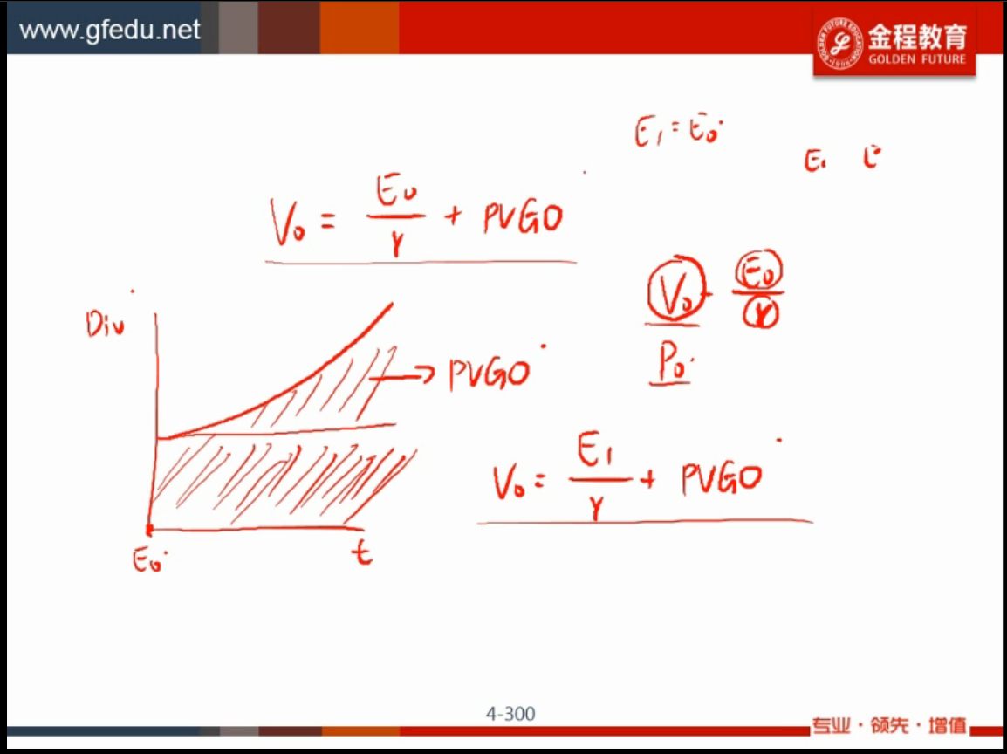

2. 用P/E算

TV5 = EPS5 \* P/E5

EPS5 = D5 / divdend payout ratio

区分给的是 trailing pe 还是 leading pe

给了trailing pe :

p0 = d0(1+g)/(r-g)

trailing pe

= p0/e0

= p0/(d0/(1-b))

= d0(1+g)/(r-g)/d0 \* (1-b)

= (1+g)\*(1-b)/(r-g)

b: retension ratio

TV5 = EPS5 \* trailing P/E5

给了leading p/e :

leading pe

= p0/e1

TV5 = EPS6 \* trailing P/E5